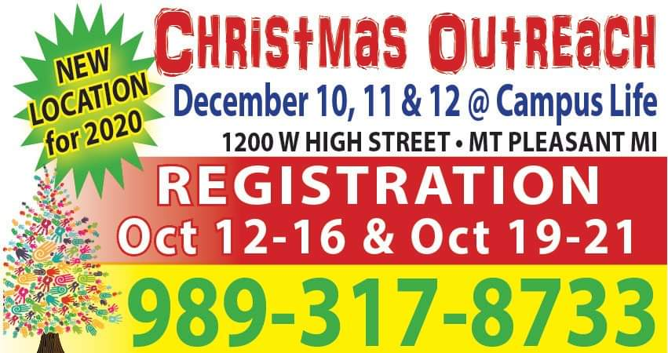

Isabella County Salvation Army assistance programs.
Emergency and self-sufficiency services are provided by the Salvation Army. Low income families, seniors, and children are the main beneficiaries of their various programs, whether that is funds for paying rent, free food from a pantry, school supplies, or Christmas toys, help is offered. There is also a low-cost Thrift Store for the public.

Emergency financial aid from Salvation Army
If you are facing eviction or a disconnection of your utilities, then emergency financial aid may be offered. This may be the service that is the most highly requested, but it is the most limited as well. Funds may be offered to assist individuals and families from areas such as Isabella and Montcalm that may be homeless without their power or if they fall behind on their housing.
All applications and requests will be reviewed and any assistance is determined on a case-by-case basis. In general, the Salvation Army will only pay a portion of your bill, so a so-called co-pay may be required as determined by the caseworker. Documentation required may be a written shut off notice, a copy of eviction letter, proof of income and more. Also, in general, assistance for paying your rent or bills may not be provided unless the applicant's household income will be sufficient to pay for the costs on their own going forward. Any financial assistance is provided as a last resort. All other private and government resources (such as LIHEAP) will be need to be applied to and explored before any help is provided by the Salvation Army. Usually all low-income applicants may be required to have a letter of denial from the Department of Human Services.
Free food pantries may pass out groceries, supplies, vouchers for shopping at local grocery stores and more. Volunteers from the centers may also offer referrals to other non-profit agencies and charities. Any type of free or low-cost food is provided to address a variety of emergency situations.
Emergency lodging, short term housing, and help in locating permanent housing may be provided for families, individuals and the homeless in the region. Any aid is only for those in an immediate housing crisis or facing eviction. Once again, applicants can’t have any other options available to them. Proof of imminent eviction and/or currently homelessness may be required as well.
Sometimes they Salvation Army may give the applicant a voucher to pay for a few nights at a local hotel/motel. All applicants must reside in Isabella, Montcalm, or Mecosta County or surrounding towns in Michigan. In addition, all applicants for housing assistance or shelter will need to demonstrate that they have plans to pay their own rent in the future and overcome the short-term hardship.
In addition to those resources listed above, other types of rental and/or mortgage assistance may be provided as funds and grants allow. This may be able to help individuals and families who are facing imminent eviction or foreclosure and then the subsequent homelessness. A security deposit will normally not be part of this program, but exceptions can be made. All assistance paid out by the Salvation Army will be determined on a case-by-case basis and as part of a broader service plan that the individual must agree to follow.
Apply for programs
The two primary Salvation Army centers to call include 1308 Burch St in Mt Pleasant (call (989) 773-4663) and 325 Linden St, Big Rapids, MI 49307. This center can be reached at (231) 796-5597. Both locations support Isabella, Montcalm, Clare and other counties. They can sell items at the thrift store, provide financial help (when offered) and give other social services.
Shepherd Fire Department
The fire department is gearing up to help our families in need. If you know of a family who would be in need this Christmas, please reply (not reply all) to this email by Friday. The fire department, along with Santa, delivers gifts and food to the families just before Christmas.

Christmas Assistance Christmas Programs Below
Agencies that help maintain family stability by preventing evictions, paying past due utility bills, and providing food assistance.

These Christmas Assistance Programs give away Toys and Gifts:

Salvation Army
Facilitates gifts through community organizations. They give toys, help with bills, help for children of prisoners, and groceries and hot meal programs. This program is made possible because of donations from individuals community organizations and corporations. If you need help this Christmas, contact your local S.A. organization. (more)

Catholic Charities
Help is facilitated through the Department of Social Services and community poverty organizations. Catholic Charities is an international faith-based organization that is dedicated to helping disadvantaged families and individuals in the community. If you need help, please contact your local Catholic Charities. You can walk in to receive free groceries from a local food bank. (More)

Free Christmas Trees
Organizations that give away Free Christmas Trees. Holiday trees are really very expensive and $30 or 40 is a lot to pay for something you will throw in the trash in a few days. Do a search for free Christmas trees near me and you will be surprised to know, there are programs that give free trees. I … Continue reading

St. Vincent de Paul
This faith-based charity helps with housing, utility payments, travel vouchers, gas cards, clothing, food, basic mandatory needs. They have programs that help ex-offenders, the disabled, beds, crib, baby supplies, and etc. They also provide Christmas, Thanksgiving assistance, toys, food, clothes (contact a chapter).

The United Way
This organization reaches the United States and worldwide. This resource provides assistance and referrals to community services. If you are looking for help for Christmas or any time. The United Way and point you in the right direction. Looking for toys for your children, clothing, furniture, help with rent, utility or more, contact this organization by dialing, 2-1-1.

Operation Homefront
Operation Homefront is an outreach to military families at Christmas and every day. They join with Dollar Tree to provide toys for children whose parents are in the military. If you would like to receive a give for your child to register with a local Operation Homefront Tory Distribution in your state. You can also receive a homecooked holiday turkey dinner. Contact to find dates this year. (find out more)

Which Programs Give Toys?
Christmas is a special time of the year, especially for children. It is very difficult for parents who love their children but cannot afford to buy toys for their children. Therefore, giving gifts and toys to children not only helps the child, but it also gives the parents the joy of know their child will have a good Xmas. These Christmas assistance programs give away toys and gifts:
- Salvation Army Angel Tree
- Toys for Tots
- Lions Club
- Catholic Charities
- Make a Wish Foundation
- Angel Tree Christmas Prison Fellowship
The programs listed here work with low-income households to provides toys and gifts for children and the elderly. There are many families that are looking for assistance each year. The key thing is to apply for a toy or gift early, so your child is placed on the list for a Christmas toy.

Do I Qualify for Christmas Assistance Programs?
Everyone won’t qualify for these Christmas assistance programs like the free toy program. Therefore, help is only given to those at-risk families. Eligibility is based on gross monthly or yearly family income. When you apply, you must present, proof of identification with a photo, proof of address, proof of income, proof of the age of the child, and proof you are the parent or guardian of the child receiving gifts. You may qualify if you receive,
- WIC
- TANF
- SNAP
- SSI
- Medicaid
- Section 8 Housing
- School Lunch Program

How Do I Apply for a Free Toy?
It is important to apply for help in October. However, December is a little too late and you may not be able to get assistance. Each program has a limited amount of funding and there are thousands of families that need help. Help is given on a first-come, first-served basis. Start contacting charities early, to make sure your child gets a toy.
You can Apply for a Gift if you are a Legal Guardian for the Child. There is a cut-off age for receiving help and groups are more likely to gift children under 12. There may be some exceptions, so check with the organization you sign up with. When applying to make sure to bring documents that support your financial situation. You will need to bring:
- Photo ID
- Proof of Income – payroll stubs, W-2 forms
- Social Security cards for each person applying for help
- Benefits documents from government agencies, unemployment benefits, child support.

Free Gift Programs
Christmas Toys and Gifts for Children
Free toys are given out every year. Many charities and community organizations are dedicated to locating charities, government, and community organizations that provide toys and gifts to children and the elderly across the United States. Also, we will show you where to get assistance with bills, during the holiday months. Many are struggling … Continue reading
Free Toys for Christmas – Christmas Help
Free Toys for Christmas. Are you looking for free toys for your children for the holiday season? Charities like the Salvation Army Angel Tree, offer Christmas assistance to at-risk families in your community. Some organizations begin taking applications as soon as October. Find out which charities give gifts and toys. Over 15 million children in the United States live in poverty. According … Continue reading

