Fidget Box / Calming Corner
Tips for creating your calming corner at school OR at home:
- Create an age/grade appropriate calming corner
- Do not use corner as a form of punishment:
  - It is important students know the calming corner is not a form of punishment but rather a safe space for them to calm down when feeling overwhelmed
- Establish classroom/home rules about corner:
  - How many students in corner at once? (Should be only one student at a time).
  - When can students go to the corner (Example: when you are feeling sad/angry/want to be alone).
  - When students cannot go to the corner (Example: during a test or reading time).
  - What is the maximum amount of time a student can stay in the corner? (Example: 5 – 10 minutes).
  - What to do in the event when a student wants to utilize corner but another student is in there? (Example: Students can wait 5 minutes and then take turns).
  - How many times a student can go to corner during the day? (Example: As many times as needed – make sure students are not taking advantage of the corner).
  - What to do if a student is starting to take advantage of the corner? (Your choice).
  - Can students independently excuse themselves to the corner or do they need permission? (Your choice).
  - What does respect towards the objects/furniture in corner look like? (Show an example at the beginning of the year to students).
  - What does calmly and quietly walking to and from corner look like? (Show an example at the beginning of the year to students).
- Give students time to adjust to corner:
  - Whether students are rushing to the corner or avoiding it at first, give students time to adjust to corner and encourage students to use it if they are feeling overwhelmed
- Location and set-up:
  - Choosing a corner in the classroom that can be both monitored yet secluded is ideal
- Calming colors:
  - Blues, greens, purples, or greys may be more beneficial to the calming process rather than reds and oranges which can increase negative emotions
- Don't be scared to get creative with designing your corner!
Fidget Box / Calming Corner
Additional Calming Corner Resources
- "Benefits of a 'Quiet Space' in your Classroom" by Sensory Intelligence Consulting
- "Self-Regulating Emotions with a Chill out Corner in the Classroom" by Teach Starter
- "The Classroom Calming Corner" by Watson Institute
- "Tier 1 Strategies for a Calm Classroom" by SCSD Behavior Matters
- "6 Ways to Make a Calm Corner Work" by Social Emotional Workshop

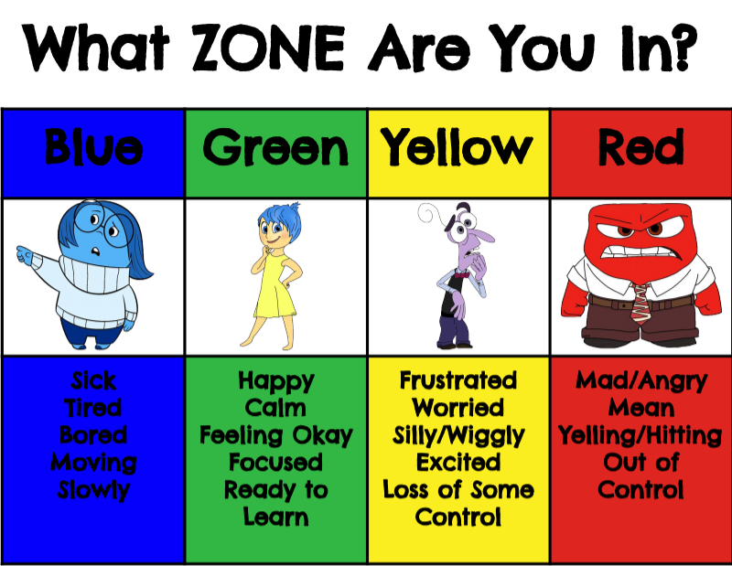
What Zone Are You In?
You can put in in your calming corner so the students can visually see how they are feeling.
Examples of Calming Corners
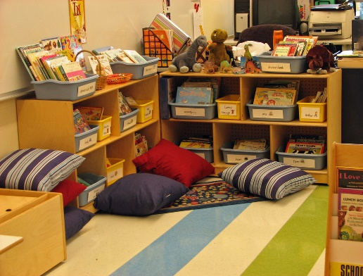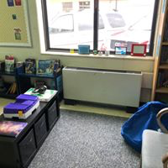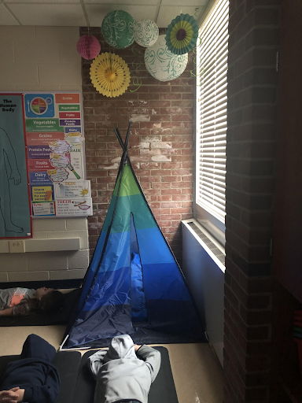**Note: Students will be allowed to pick one fidget from the fidget box, teachers or parents will clean this fidget after each use.
This Photo by Unknown Author is licensed under CC BY-SA-NC
Fidget Box / Calming Corner
"A calming corner is a designated space that children can retreat to when they feel overwhelmed and overloaded by the sensory input from the immediate environment."
"A calming corner gives an overwhelmed student time and space to calm their sensory system and take control of their emotions again."
Benefits:
- Improved mood
- Fewer disruptive behaviors
- Decreased anxiety and fear
- Improved communication
- Enhanced interpersonal interactions
- Promotes independence
- Allows children to take charge of their own behavior
- Children begin to understand their own feelings
- Maintain classroom efficiency

Name the Calming Corner:
- Have fun with your students / children and come up with a fun name for your “calming corner”.
- Examples: zen zone, safe place, break zone, chill-out corner, cool down corner, destress zone, quiet space.
Creating Your Calming Corner at Home OR at School
Suggested items for calming corner area:
- Mini-trampoline • Swings • Rocking chair • Rug • Pillows / cushions • bean bags • Canopy Tent
Suggested items to put in the calming corner area:
- Exercise balls • Weighted blankets • Stuffed animals • Sound machines • Lava lamps • Fidget toys (Fidget spinners, rubrics cube, fidget cube, squishes’) • Noise cancelling headphones • Beads and string • Headphones with music • Play-Doh or modeling clay • Sunglasses • Fish tank • Sand tray • Art and coloring supplies • Word searches • Activity sheets • Timers • stress balls • Organizer caddy • Finger puppets • Pinwheels • Fidget puzzle toys

Use For:
- Classroom OR at home
- An opportunity/option
- A place to find comfort/sense of safety and regain control
- Introducing and allowing students to try it out before they become upset
Do not use:
- As a consequence
- As a directive
- As fun reading spot

