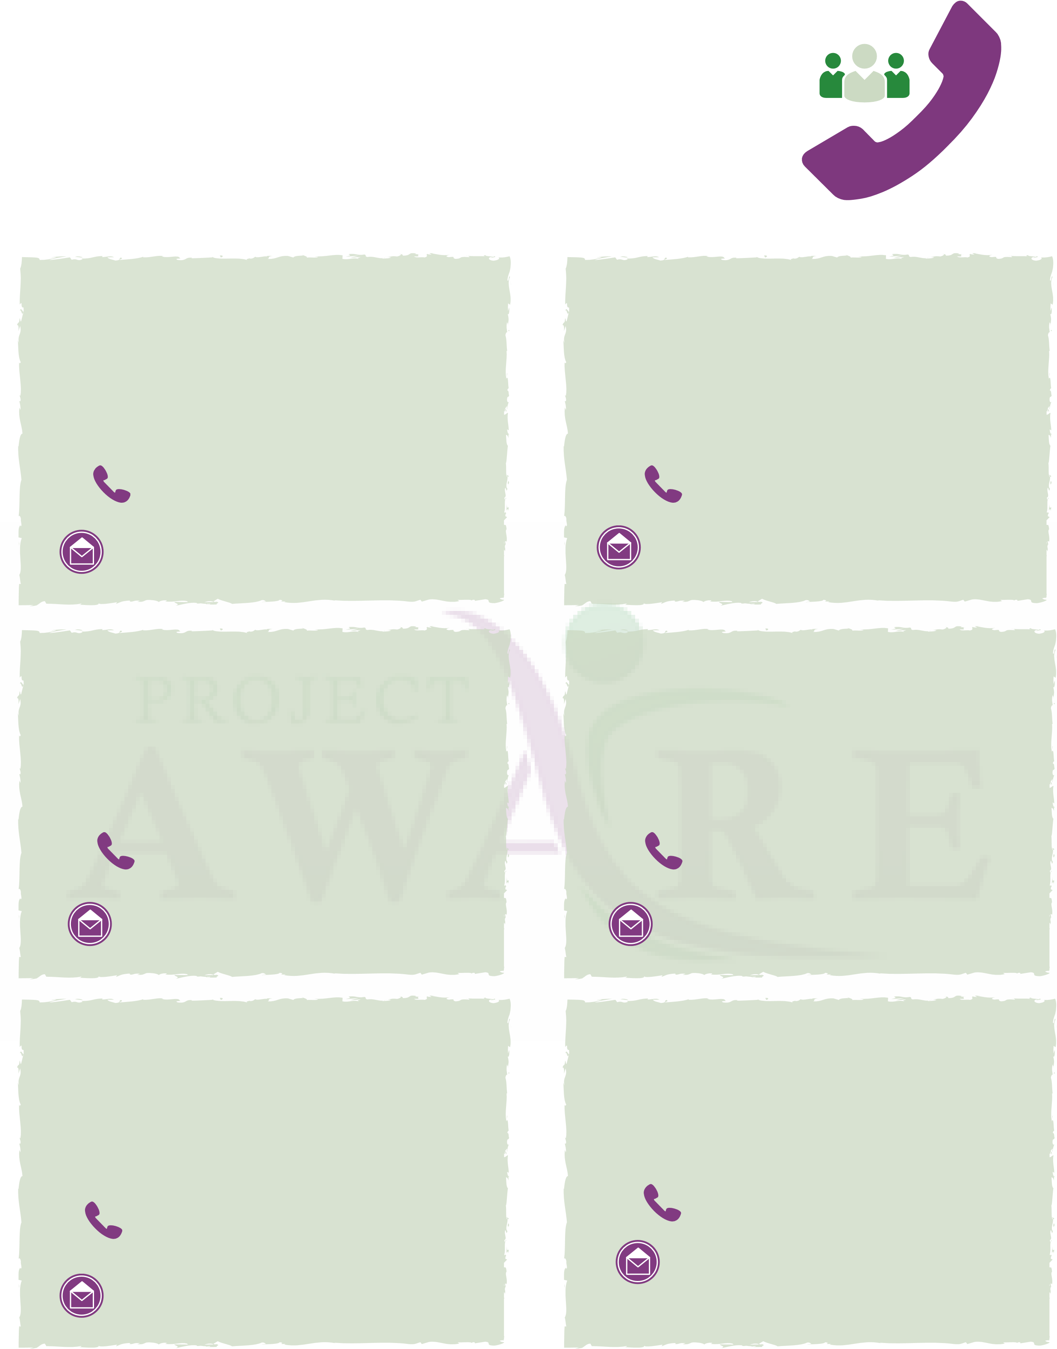
Project AWARE Contact Sheet
All Project AWARE staff are available from 8am-5pm Monday-Friday.
Project AWARE/SCA Project AWARE/SCA
Counselor Counselor
Tahsheenah Foley Michelle Klingensmith
989-444-8182 989-444-8319
TahFoley@sagchip.org

Project AWARE Project AWARE
Coordinator Co-Coordinator
Project AWARE
Co-Coordinator
Trisha Bassett
989-824-0035
Kehli Henry Trisha Bassett
989-444-9367 989-824-0035
KHenry@sagchip.org TBassett@sagchip.org
MPPS Community SPS Community
Project Manager Project Manager
Alexis Syrette Judy Pamp
989-824-0114 989-444-8252
JuPamp@sagchip.org
AlSyrette@sagchip.org jpamp@shepherdschools.net

Crisis Lines
SCIT Behavioral Health Available 8am-5pm989-775-4850
5 days a week
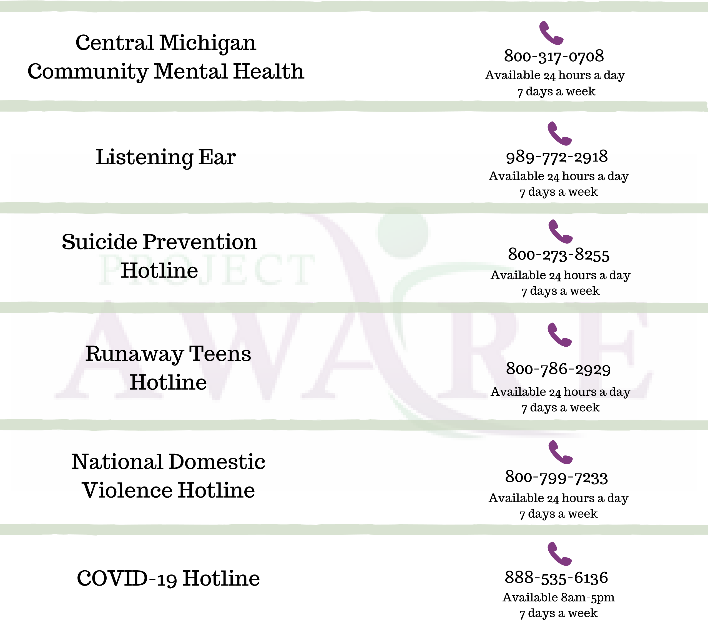
After Hours Line 989-775-4700
Certified Peer Support ₈₈₈₋₇₃₃₋₇₇₅₃ Specialist Warmline: Available 10am-2am7 days a week

